A boy from the Pā speaks -
Hidden in plain sight

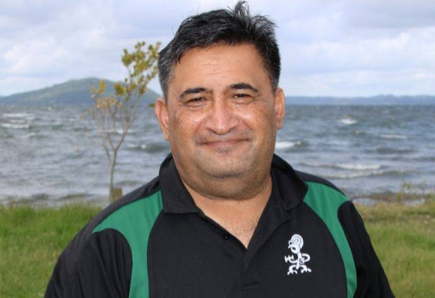
I am a boy from the Pā - Ōhinemutu and Te Koutu. Throughout the years I have seen our people flourish like flowers reaching out to the sun. I have seen the petals of others that have dwindled and faded away.
I’d like to talk to you about what I believe makes the difference. These are the gifts left by our tūpuna to guide us. They are all around us, they talk to us every day, and they are all hidden in plain sight.
I can’t wait to share my kōrero
Kingi Biddle QSM

Tēnā koutou katoa. My name is Kingi Biddle. I am from the Waka of Te Arawa, Mataatua and Tainui.
I have spent my working life involved in communication. Whether it be in Radio, Television or public speaking, I have a heart to share messages with people, and helping them learn to share their kōrero too.
My greatest achievements are being a husband, Dad, son, brother, relation and friend. My biggest faith is in the goodness of people. Our ability to overcome with a spirit that unites us all.
In my kōrero I will be talking about simple things that our ancestors have left us to ensure clarity of spirit, emotions and mind.
Ki te rehurehu taku kite, kāre ahau e tae atu - if the way is unclear, I will not get to where I am going
Ka nui te mihi

Kingi

